CHALLENGES FACING DATA COLLECTORS IN SOUTH SUDAN: CASE STUDY GOK STATE- CUEIBET

BY
MOSES MABOR TOM GURIC

AN RESEARCH PROJECT SUBMITTED IN PARTIAL FULFILLMENT OF THE REQUIREMENT FOR THE AWARD OF DIPLOMA IN MONITORING AND EVALUATION IN THE UNIVERSITY OF STRATEGIA NETHERLANDS

NOVEMBER 2019

DECLARATION
This management research project is my original work and has never been presented in any other university or college for the award of Diploma or Certificate.

Name: _____________________Signature: _________________ Date____________
MOSES MABOR TOM
Admission Number: 330/05/2019
Course code: D001

Declaration of the Supervisor/Lecturer
This management research project has been submitted for examination with my approval as the University supervisor.

Name: _____________________Signature: _________________ Date____

Retamo Fredrick
Institute supervisor
DEDICATION
I sincerely dedicate this research project to my dear mother Ayuol Ater Dut and the entire family of Guric Riak for their encouragement and support both financially and morally, God’s love for you shall endure forever.

ACKNOWLEDGEMENT
First and foremost, I want to thank the Almighty God for the gift of life, good health and strength throughtout my studies. I appreciate and wish to extend my best wishes and gratitude to all whose assisstance and encouragement enabled me to complete this project. Special thanks to my supervisor for his positive criticism on my work,without his valuable input, dedication, expert support and encouragement, I would haven’t reach this stage, otherwise thank you, God bless you.
I also thank the management team of Strategia Netherlands, Water For Lakes Project (WFL) and MOTT MACDONALD for the support and services they have contributed towards my studies in the institution.
I would like to thank the entire team of Green Village Network (GVN) whose love and support has enabled me to pursue my studies with a lot of fulfillments. Special thanks to Mr. Andrew Sebit Mathen, GVN Program Manager for granting me this opportunity on capacity building which is our main challenge. Thank you very much Team Leader (TL).
I wish also to thank my friends and relatives for good times we shared together. I cannot forget to mention Mr. Marik Abraham Malok for his valuable support both morally and materially, thank you for that Ariko.

And finally, to Ms. Jacqueline Wairimu W, the WASH Expert, Water for Lakes project thank you so much for providing us with this opportunity, my appreciations for you are beyond description, otherwise thank you Madam.

ABSTRACT
The purpose of this research project is to know the challenges facing data collectors in humanitarian organizations operating in Gok State - Cueibet.
The study was carried out in Gok State- Cueibet located at the centre of South Sudan, on the main road connecting Rumbek and Wau in an area formerly known as Lakes State of Bhar el ghazal region. The main aim was to indentify the challenges facing data collectors, the effects of wrong data and how to prevent those challenges.

The study was undertaken within a period of one month that is November 2019.
The approach used in this study is mixed methods research approach for collecting, analyzing and presenting data using tables, pie charts, graphs and figures. Because the assumption of the mixed methods research approach is that the combination of qualitative and quantitative approaches provides a more complete understanding of a research problem than either approach alone. The researcher targeted population of 45 respondents from Gok State-Cueibet and they were comprised of people of different education background, race, age groups, religion and social status. The target population was chosen at random, some were found in the offices, at school, hospital and in public institutions.
As per recommendations, through capacity building, project Managers, Project coordinators, Project Staffs including monitoring and evaluation officers or specialists to educate them on how to prevent those challenges and to strengthen them with knowledge and skills to overcome them.
In conclusion, the researcher has identify the challenges facing data collectors in Gok State-Cueibet, identified the common causes of wrong data collection and the preventive measures of the problem as well as the effects.

TABLE OF CONTENT
DECLARATION………………………...……. ii
DEDICATION iii
ACKNOWLEDGEMENT iv
ABSTRACT v
TABLE OF CONTENTS vi
ABBREVIATIONS vii
DEFINITION OF KEY TERMS viii

CHAPTER ONE
INTRODUCTION OF THE STUDY
1.1 Introduction 1
1.2 Background of the study.......................................................................................1
1.2 Profile of Gok State Cueibet 1
1.3 Statement of the Problem 3
1.4 Objectives of the Study 4
1.5 Research Questions 5
1.6 Significance of the Study 5
1.7 Limitations of the Study 5
1.8 Scope of the Study 6

CHAPTER TWO
LITERATURE REVIEW
2.1 Introduction 7
2.2 Review of Theoretical Literature 7
2.3 Review of Analytical 21
2.4 Summary 23
2.5 Conceptual Framework 24

CHAPTER THREE
RESEARCH DESIGN AND METHODOLOGY
3.1 Introduction 26
3.2 Study Design 26
3.3 Target Population 26
3.4 Sample Design 27
3.5 Data Collection Procedures 27
3.6 Data Analysis Methods 29
CHAPTER FOUR
DATA, ANALYSIS, PRESENTATION AND INTERPRESENTATION OF FINDINGS
4.1 Introduction …...30
4.2 Presentation of Findings …......30
4.3 Summary of Data Analysis …...46

CHAPTER FIVE
SUMMARY OF FINDINDGS, CONCLUSION AND RECOMMENDATIONS
5.1 Introduction …...48
5.2 Summary of the Study Findings …...48
5.3 Conclusion …...49
5.4 Recommendations …...49
5.5 Suggestion for Further Study …...50
REFERENCES 51

APPENDICES
Appendix I Questionnaire

LIST OF ABBREVIVATIONS

GVN Green Village Network
WFLP Water For Lakes Project
WASH Water Sanitation and Hygiene
TL Team Leader
MDGs Millennium Development Goals
SSNBS South Sudan National Bureau of Statistics
LFA Logical Framework Analysis
M&E Monitoring and Evaluation
NGO Nongovernmental Organization
OECD-DAC Organization for Economic Co- operation and Development, Development Assistance Committee

DEFINITION OF KEY TERMS

According to (Bloomsbury English Dictionary) defines data as: “information, often in the form of facts or figures obtained from experiments or surveys, used as a basis for making calculations or drawing conclusions”.

Data collection is the process of gathering and measuring information on variables of interest, in an established systematic fashion that enables one to answer stated research questions, test hypotheses, and evaluate outcomes.
Monitoring: Is the continuous assessment that aims at providing all stakeholders with early detailed information on the progress or delay of the ongoing assessed activities. It is an oversight of the activity's implementation stage. Its purpose is to determine if the outputs, deliveries and schedules planned have been reached so that action can be taken to correct the deficiencies as quickly as possible (Gage, Dunn, 2009)

Evaluation: Evaluation is the user-focused, systematic assessment of an ongoing (or completed) project’s design, implementation and results.

CHAPTER ONE

INTRODUCTION OF THE STUDY

1.1 Introduction
The chapter presents the background of the study, statement of the problem, objectives of the study, significance, limitations and the scope of the study. This brings about good understanding of what the study is expected to attain in the long run.
1.2 Background of the study
JUBA, South Sudan — According to the U.N.’s International Organization for Migration, which was one of the first bodies to develop its own internal data protection policy, the No. 1 principle when collecting data is its lawful and fair collection. This means aid agencies and aid workers, among others, has a responsibility to research international standards and national data protection legislation in the country of operation.
Additionally, before beginning any data collection efforts, it’s important to be clear on what information is needed and to ensure data can be collected or synthesized in an ethical and accurate way, said Katie Rickard, global coordinator for humanitarian research initiative REACH, which regularly operates in South Sudan.
“Too many times data collection efforts start without a clear sense of the specific objective and without full confidence the data collected will be accurately reflecting the views and reality of the population of interest,” Rickard said. The populations researched are often extremely vulnerable and it’s unethical to take their time without a clear sense of the purpose, she added.
In South Sudan, where the humanitarian situation is dire and the gap between the demand and resources is wide, aid groups have started pushing for a more evidence-based response, trying to use data and information to better understand the context and make decisions in a calculated way.
Monitoring: is a continuous assessment that aims at providing all stakeholders with early detailed information on the progress or delay of the ongoing assessed activities. It is an oversight of the activity's implementation stage. Its purpose is to determine if the outputs, deliveries and schedules planned have been reached so that action can be taken to correct the deficiencies as quickly as possible.
An evaluation: is a systematic and objective examination concerning the relevance, effectiveness, efficiency and impact of activities in the light of specified objectives. The idea in evaluating projects is to isolate errors in order to avoid repeating them and to underline and promote the successful mechanisms for current and future projects.
An important goal of evaluation is to provide recommendations and lessons to the project managers and implementation teams that have worked on the projects and for the ones that will implement and work on similar projects.
The Paris Declaration on Aid Effectiveness (PDAE) in February 2005 and the follow-up meeting in Accra underlined the importance of the evaluation process and of the ownership of it’s conducted by the projects' hosting countries. Many developing countries now have M&E systems and the tendency is growing.
In Gok state the main challenges that the researcher had identify from the respondents are, language barrier, resistance from the community leaders and respondents, insecurity, roads accessibility, transport challenges/ logistical issues and conflicts with compensation.
The researcher had also identify the solutions to the problems facing data collectors by; training of staff on safety and security management, providing means of transport for data collectors, Data collectors should keep participants or respondents information confidential, data collection projects should be well financially sponsored.

1.3 Statement of the Problem

The following are the challenges faced by data collectors in south Sudan: Case study Gok State-Cueibet
South Sudan has been affected by civil wars between Sudan people Liberation (SPLA/M) and the Northern Government under (NCP) which has lasted for 21 years.
Again in 2013, 15 December armed conflict broke out among the same south Sudanese national army which split in to two, the Sudan People Liberation Movement/Army and the Sudan People Liberation Movement/Army in - Opposition (SPLM/A-IO). These two protracted conflicts have left many organizations with no proper management some organization have decided cook data in their conducive environments and leaving going to the field to get rightful information because of insecurity in some areas, in Gok State particular, there are number of factors that are affecting data collectors negatively The main challenges that the researcher had identify from the respondents are, language barrier, resistance from the community leaders and respondents, insecurity, roads accessibility, transport challenges/ logistical issues and conflicts with compensation. And they can be address through training of staff on safety and security management, providing means of transport for data collectors, Data collectors should keep participants or respondents information confidential, data collection projects should be well financially sponsored.

1.4 Profile of Gok State-Cueibet
Cueibet is the capital town of Gok state which makes up 32 states of South Sudan. It is located in the central Bahr el Ghazal region, on the main road connecting Rumbek and Wau; it was formerly part of Lakes state. Gok state border Tonj state to the west and Western Lakes to the east. The state had a population of 117755 according to (2008 censes).
Before the creation of Gok as a state, Cueibet was a county under former Lakes state headed by a commissioner as the highest authority of the government in a county (Paanluel wel media.Ltd, 2017).

With the regard to Administrive division, Gok state is currently consisting of nine counties Cueibet county the capital of the state, Abiriu county, Duony county, Anyar-nguan county,Waat-adol county, Malou-pech county, Joth-mayar county, Ngap county and Cueibet county and at the same time, the capital of the state (Gok) and it is where am conducting this research.

1.5 Objectives of the Study

1.5.1 General Objective

The main objective of the study was to know the challenges facing data collectors in South Sudan: Case study Gok State- Cueibet

1.5.2 Specific Objectives
- To determine the main challenges facing data collectors
- To identify the solutions to the problems facing data collectors
- To determine the ways of preventing the challenges facing data collectors

1.5 Research Questions
1. What are main challenges facing data collectors in your organization?
2. Briefly explain the methods used for collecting data in your organization
3. What are the causes of wrong data collection in the organization concern?
4. In your opinion suggest ways in which the issue of wrong data collection can be improved to facilitate the smooth running of the project.
5. Discuss the qualities of a good data
6. Briefly describe the importance of data collection? 7. What are the factors consider when collecting data?
8. Discuss the qualities of a good data.

1.6.1 Significance of the Study

This research study will benefit the humanitarian organizations operating in Gok by gaining in insights concerning the challenges, solutions, and the preventives measures that the researcher had identified.

1.6.2 Researchers
Researchers who are doing related study may use this research as their secondary data. The research will also propose other areas which the researcher can explore further. They can also do another research in the same way to weight the trend.

1.7 Limitation of the Study

1.7.1 Confidentiality
Confidentiality was a major point of concern as some respondent were reluctant in giving details to someone they consider a stranger, thinking that the researcher would use the information to their competitive advantage. The researcher overcame this challenge by producing a letter of introduction which was attached to the questionnaires. This assured them the purpose of the study and that the information they give shall be considered confidential.

1.7.1 Uncooperative Respondents

The study encountered poor cooperation from respondents. Moreover, the respondent restricted themselves to the responsibilities and duties. This lead the researcher to be ignored when enquiring and acquiring relevant information, however, the researcher informed the respondents on the importance of the study and cited the top beneficiaries.

1.8 Scope of the study
The study was carried out in Gok State-Cueibet which is located at Rumbek-Wau Road. The main aim was to identify the challenges facing data collectors in South Sudan: Case study Gok State-Cueibet. The departments under study included top management, middle and support staff management from administration department. The study was undertaken within a period of one month of November 2019

CHAPTER TWO
LITERATURE REVIEW
2.1 Introduction
The review is an important part of the objective approach to research in all fields of enquiry. This is aimed at identifying the research gaps to the existing literature and emphasizing on the need to carry out this study which is concerned with the identification of the challenges facing data collectors in South Sudan: Case Study Gok State- Cueibet. The purpose of this literature review is to provide the researcher with means of getting to the frontiers of knowledge of the issue under investigation. To this end, the present chapter covers a review of theoretical literature review of analytical literature of analysis and gaps to be filled, a summary of the chapter and the conceptual framework.
2.2 Review of Theoretical Literature
2.2.1 Monitoring and Evaluation
Monitoring and evaluation are defined differently based on an organization’s needs. Evaluations are principally systematic assessments usually looking at program design, implementation or results set against a range of criteria. Save the Children and many others rely on the OECD to develop internationally recognized standards for the practice of monitoring and evaluation. Common types of development evaluations today are: prospective (scenario mapping for program design, forecasting costs and potential results), formative (the progress of a project being implemented), summative (final report on outcomes achieved), and impact evaluation (IE) (effect from the intervention continuing beyond the program end date) (IPDET Handbook) Module 1, 2007, p.13-15). Summative evaluations are the most commonly performed evaluation because they show immediate outcomes or project results. Formative evaluations like baseline assessments and mid-point evaluations are usually only used for larger or longer-term programs. Impact evaluations have become a desirable standard among large funders, typically governments, foundations or corporations. Approaches for impact assessments from different fields of research have been lacking cohesion in their methods, “In recent years, there have been several efforts to integrate social and environmental impact assessments into more coherent forms (see Barrow 1997); impact analysis, on the other hand, was essentially confined to an assessment of impact several years after a project had ended” (1999, p.18). Roche emphasizes the challenges of theoretical approaches, methods, and techniques being used to uncover the social effects of change. Assessments that integrate social and environmental factors capture more of the impact from given contexts. Roche describes one innovation in the organization of evaluation planning as the “next generation of planning in international development agencies” called Logical Framework Analysis (LFA) or Log Frame (1999, p.18). LFA’s attempt to “set out a clear hierarchy of inputs, activities, and objectives and to relate these to assumptions made about the external environment. Today the logical framework and its variants are the most common planning framework used by bilateral and multilateral agencies” (Roche, 1999, p.18-19). With impact evaluations, evaluators need to move beyond the project’s LFA to determine whether the inputs, outputs, and outcomes caused the long-term change that planned. Impact analysis also requires the evaluator to determine whether the change can be attributed back to the implementing organization or if other factors were involved. Some evaluations are specially structured to analyze systems and trace their processes. The systems thinking approach is an appropriate strategy for evaluation since international development organizations work globally, across all sectors and across many professions, academic disciplines and industries. Cabrera, Colossi & Lob dell (2008) note that systems thinking is suitable for complex programs specifically because it “is interdisciplinary and may act as a bridge between the physical, natural, and social sciences” and that it “may also act as a bridge between academic, professional and lay communities” (Cabrera, p.300-301). This means that this approach may also generate the most understanding between the actors in these different sectors. M&E systems have developed within organizations to manage the development evaluation process. Directions from the OECD DAC on the institutional structure for managing evaluations asserts, “organizational aspects must address three requirements: developing a policy and a set of guidelines for evaluation; ensuring impartiality and independence; linking evaluation findings to future activities… by having a central unit responsible for evaluation reporting directly to…the agency head” (OECD, 1991, p.6). The OECD DAC further stipulates that an M&E system needs to have “a critical mass of professional evaluation staff in order to have sufficient expertise in their various fields of activity and to ensure the credibility of the process” (OECD, 1991, p.7). M&E systems need a strategic plan to account for and coordinate agency-wide evaluation objectives and activities. OECD DAC directions for evaluation programming dictate the need for one overarching plan with a timetable for prioritizing and evaluating “a more comprehensive scale and an aggregation of evaluation results” (OECD, 1991, p.8). Furthermore, “credibility of evaluation depends on the expertise and independence of the evaluators…” and “evaluation should report successes as well as failures” (OECD, 1991, p.7). Since there are usually many people with a stake in evaluations, it is important for the evaluation process to be transparent. In that light, one key component of an overall evaluation plan is its assurance of systematic dissemination of evaluation reports and a synthesis of results through annual reports, briefs, meetings and workshops in various settings. One significant area not addressed by the OECD DAC guidance is records management regarding evaluation reports. Evaluation findings are the evidence needed to support programs and advocate for policy changes. Key questions should be answered in evaluations so that “lessons learned and the recommendations provide the link between the results of the evaluation and future policy and programme development” (OECD, 1991, p.10). Most of all, M&E systems should facilitate feedback from stakeholders and link it to future activities. This ensures that future policies are developed with the concerns of stakeholders in mind and this increases the ownership of stakeholders within the development process.
The practice of development evaluation is thought to have grown out of expansions in educational program evaluation stirring in public schools and universities. According to a study by Madaus, Stufflebeam and Kellaghan (2000) there have been seven stages in the development of program evaluation beginning in 1792 with the “first documented formal use of evaluation…[which] utilized the quantitative mark to assess students’ performance (Hoskins, 1968)” (Hogan, 2007, p.3). Of course, master craft workers were judging their protégés handiwork and learned scholars were arbitrating arguments long before, probably thousands of years before, this stage described by Madaus et al. One place where evaluation became more formalized and formulaic was in manufacturing. The codification of evaluation took place step by-step in response to rising demands for uniformity, replicability and accountability in the modernizing industrial world largely due to the US government vis-à-vis US military spending(Hogan, 2007, p.4). The demand for military equipment for World War II led to improvements in the practice of evaluation just as development aid grew during the post-World War II era when the United States used it to help rebuild European states devastated by the war. Education reform and education spending in the same post-World War II era brought increased attention to criterion-referenced testing and objective-based testing (OBT). OBT experienced a boom as “Bloom, Engelhart, Furst, Hill, and Krathwohl (1956) gave objective based testing advancement when they published the Taxonomy of Educational Objectives” (Hogan, 2007, p.5). Furthermore, evaluation in education grew exponentially when “Congress enacted the [1958] National Defense Education Act (NDEA) which poured millions of dollars into new curriculum development projects… (Stufflebeam, Madaus, & Kellaghan, 2000). An additional push for program evaluation in education came with the 1965 Elementary and Secondary Education Act (ESEA) which “mandated the government to assess student performance and teacher quality standards and provided resources (first US government budgetary set-aside for evaluation) to undertake these activities, thereby institutionalizing evaluation” (IPDET Handbook Module 1, 2007, p.29). These congressional acts and the accompanying funds provided a much needed boost for the field of program evaluation. The practice of development evaluation advanced in this post-World War II period as donor agencies began to recognize evaluation as an essential management tool and “began to emerge both at country level and in the UN system in the early 1950s. Since then, it has evolved slowly and unevenly” (UN Taskforce, 1984, p.7). The latter part of the 1950’s and throughout the 1960’s was a slow period of country level focus on M&E where the United Nations “promoted building of national development planning capabilities” (UN Taskforce, 1984, p.9). Building capacity in M&E was envisioned to increase ownership over the development process for the governments and citizens in the countries where development programs were being implemented. Interest and activities in developing M&E varied considerably during the 1960s and 1970s. Program monitoring and evaluation “such as in connection with development projects or technical assistance activities – were limited in concept and scope. They were concerned more with disbursement and delivery of physical inputs and outputs than with the nature of and impact on beneficiaries. In recent years, however, this has been changing (UN Taskforce, 1984, p.7). In the 1970’s and 1980’s, development evaluation “became a full-fledged profession in many OECD countries” and many monitoring and evaluation approaches, methods and standards were created (IPDET Handbook Module 1, 2007, p.30). It wasn’t until the 1990’s that development evaluation ‘expanded and integrated’ into professional associations with standards for the evaluation of international programs (Hogan, 2007, p.6). Now there are professional evaluation organizations, such as the American Evaluation Association, evaluation institutes, such as The Evaluators’ Institute at George Washington University, and many online e-learning courses.
2.3 Review of Analytical
2.3.1 Current challenges of M&E System
The practice of development evaluation is still maturing and evolving. For over 50 years the OECD has been working with governments to “understand what drives economic, social and environmental change” and promote “policies that will improve the economic and social wellbeing of people around the world” (OECD, n.d., Our Mission). Nonetheless some evidence suggests that “most current attempts to promote institutional learning, impact assessment, and greater accountability in the NGO sector” are insufficient (Roche, 1999, p.3). The context for development evaluation is facing new challenges caused by shifts in the structure of development assistance. Accountability has taken a new direction, downward, valuing beneficiary empowerment, in addition to donors, governments and civil society. The push for participation of beneficiaries in development evaluations is increasingly political and requires involving many more people. Moreover evaluation planning now needs to consider “managing for results and the Millennium Development Goals; partnership principles; new aid modalities such as sector approaches and general budget support; [and] going beyond aid to policy coherence” (Conlin, 2008, p.195). Roche continues to identify factors whose syntheses elements combine to produce a growing gap between the rhetoric of agencies and the reality of what they achieve. Figure 1.1: The vicious circle • Increased competition between NGOs • Increased pressure to show results and impact • Lack of professional norms and standards • Poor learning and accountability • Growing need for profile for fundraising and [advocacy] work (1999, p.2) energies contribute to breakdowns in development organizations These factors directly affect development evaluation systems and cause problems for M&E oversight and actually using the findings and recommendations from evaluations. Further issues arise when organizations cannot meet program evaluation needs and standards. Not only are evaluations technically complex and multifaceted, so are M&E systems. The system that manages program evaluation needs to be evaluated itself. A study of the evaluation systems of OECD members found “that most development agencies now have a clear evaluation policy providing a clear mandate for the main evaluation unit and protecting the independence of the evaluation function” (OECD DAC NDE, June 2010, p.11). The study notes upward trends for joint evaluations and evaluation with wider scopes (OECD DAC NDE, June 2010, p.11). Some challenges persist, including “human resource capacities, supporting lesson learning and ensuring the systematic take up of evaluation findings to improve development effectiveness” (OECD DAC NDE, June 2010, p.11). An organization struggling to manage its M&E system might be aware of its system challenges or it may not. This is why it is essential to feature feedback mechanisms in the evaluation process: These would include such measures as evaluation committees, seminars and workshops, automated systems, reporting and follow-up procedures. Informal means such as networking and internal communications would also allow for the dissemination of ideas and information. In order to be effective, the feedback process requires staff and budget resources as well as support by senior management and the other actors involved. (OECD, 1991, p.11) Organizations interested in enhancing the accountability effectiveness of their M&E system should review their monitoring and evaluation policies and compare them to 1) OECD standards and 2) their practices. Discrepancies between these sources point to challenges that need to be addressed.

2.4 Summary of gaps to be filled
The study therefore aimed at filling the gaps identified in previous study by investigating very concept through to create solutions, while identify the challenges facing data collectors the in Development Sectors
Despite improvements, challenges remain in both collecting and analyzing information: “Data is hard in South Sudan,” Steve O’Malley, country head at OCHA, told Devex.
Decades of consecutive wars have made it hard to gather national statistical data set, which means the country has had to build up data through other resources. A 2008 census and a 2010 Household Health Survey can be used to make estimates, for example, but the intervening years saw a lot of displacement and movement, O’Malley said, adding that this is the kind of baseline data that needs updating.
Some aid workers using the information want to see more trend projections and routes taken by people, which would help target and potentially reduce overuse of resources, cluster coordinator Mayer said. She’d also like to see more use of biometric registration throughout the country.

2.5 Conceptual Framework
This section prospects a schematic interpretation of the conceptual framework as shown in the figure below. Conceptual framework a tested, evidence-based model for a development or relief intervention.

Figure 2.1 Conceptual Framework
Independent variables Dependent Variables
Data collection
Monitoring
Challenges facing data collectors in the development projects
Evaluation
Accountability

Source: Author (2019)

2.5.1 Data Collection
Data collection is the process of gathering and measuring information on variables of interest, in an established systematic fashion that enables one to answer stated research questions, test hypotheses, and evaluate outcomes.

2.5.2 Monitoring
Is the continuous assessment that aims at providing all stakeholders with early detailed information on the progress or delay of the ongoing assessed activities. It is an oversight of the activity's implementation stage. Its purpose is to determine if the outputs, deliveries and schedules planned have been reached so that action can be taken to correct the deficiencies as quickly as possible
2.5.3 Evaluation
Evaluation is the user-focused, systematic assessment of an ongoing (or completed) project’s design, implementation and results.
2.5.4 Accountability
Accountability is a commitment to balance and respond to the needs of all stakeholders—including project participants, donors, partners and the organization itself—in the activities of the project.

CHAPTER THREE
RESEARCH DESIGN AND METHODOLOGY
3.1 Introduction
This chapter presents description of the research methodology that shall be used to answer questions described in chapter one of this research study. The methodology to be used in the research study includes research design, target population, sampling design and data collection and analysis procedures.
3.2 Research Design
The research design used during conducting the study was descriptive research. It (descriptive research) was used to obtain information concerning the current status of the phenomena to describe "what exists" with respect to variables or conditions in Gok State. This method involved range from the survey which describes the state of things, the comparable study which investigates the relationship between variables. Descriptive studies are not only restricted to fact finding but may often result in the formation of important principles of knowledge and solution to significant problems. They are more than just a collection of data since they involve measurement, classification, analysis and interpretation (David, 2005).
3.3 Target Population
Schindlers (2003), described the target population as the complete set of individual’s area of objects with some common characteristics to which the researcher wants to generalize the result of the study. According to Kothari (2004), target population is a universal set of the study of all members of real or hypothetical set of people, events or objects to which an investigator wishes to generalize the result. In this case the target population was 45 employees from different organizations operating in Gok, where it comprised levels of management as of the top, middle and support staff levels of management from administration department.

3.5 Data Collection Instruments and Procedure

3.5.1 Primary Data
According to Web monitoring Inc (2019), primary data is the data observed or collected directly from firsthand experience.
Therefore in this study Questionnaires were sent to a number of persons seeking their responses that can be tabulated and treated statistically. It is a form for securing answers to questions from respondents. The researcher used both structured and unstructured questionnaire which have both structured and semi-structured questions. There was a pre-determined question whereby respondents were served with the questionnaire and are given a chance to fill. The types of questions used were both open and closed ended. Closed ended questions were used to ensure that the given answers were relevant. The researcher phrased questions clearly to make dimensions along which respondents were analyzed. In open-ended questions, space shall be provided by the respondent, thus giving him/her freedom to express their feeling.
3.5.2 Secondary Data
Secondary data is the published data and data collected from other parties or in the past (Web monitoring (2019).
Materials available in Gok State- Cueibet like magazines, newspapers, journals and World Wide Web in relation to this study were used. And before the use of available materials the researcher wrote a letter of permission to the administration concern such as South Sudan National Bureau of Statistics (SSNBS) asking for permission to have access to their published data.
3.5.3 Validity and Reliability of Research Instruments
According to Kothari (2004), validity is the accuracy and meaningfulness of inferences which are based on the research results. It is the degree through which results obtained from the analysis of data represent the phenomenon under study while reliability is a measure of the degree to which a research instrument yields consistent results after repeated trials. It involved administering the same instrument a number of times to the same group of subject.
The researcher gets authorization from relevant departments of the organizations in Cueibet to circulate questionnaires. To ensure reliability and validity questionnaires were pre-tested on 45 respondents. These respondents were included in the final study. The questionnaires were then corrected before the final distribution is done.

3.5.4 Administration of Questionnaires
Questionnaires were used in the study which was hand-delivered and collected after a few days. The types of questions to be used included both open and closed ended. Closed ended questions were used to ensure that the given answers are relevant. The research phrased the questions clearly in order to make clear dimensions along which respondents will be analyzed. In open ended questions, space was provided for relevant explanation by the respondents, thus giving them freedom to express their feelings. This method was considered effective to the study in that; it created confidentiality. The presence of the researcher was required as the questionnaire was self-administered.

3.6 Data Analysis Methods
According to Kothari (2004), data analysis procedure includes the process of packaging the collected information putting in order and structuring its main components in a way that the findings can be easily and effectively communicated. After the fieldwork, before analysis, all questionnaires were adequately checked for reliability and verification. Editing, coding and tabulation were carried out. The data collected will be analyzed using simple qualitative and quantitative methods and presented using tables, figures and charts.

CHAPTER FOUR
DATA ANALYSIS, PRESENTATION AND INTERPRETATION OF FINDINGS
4.1 Introduction
This chapter undertook to analyze and discuss the data collected from the respondents in relation to research objectives and questions. Analysis was presented using frequency tables and percentages, presented in graphs charts and interpreted thereafter. The open ended questions were analyzed in qualitative nature and closed ended questions analyzed in quantitative nature.

4.2 Presentation of Findings
4.2.1 Response Analysis
Table 4.1 Response Analysis
Respondents Category | Frequency | Percentage
Response | 40 | 89
Non-response | 5 | 11
Total | 45 | 100
Source: Author (2019)

Figure 4.1 Response Analysis

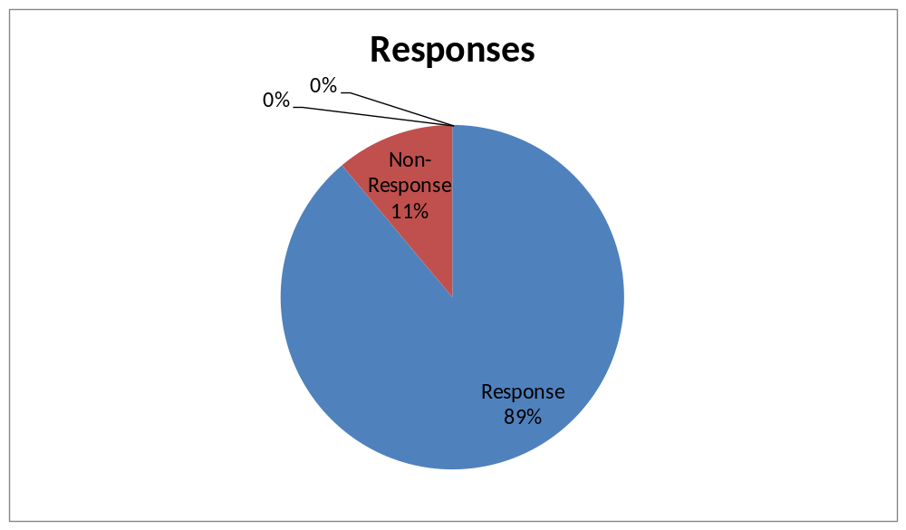

Source: Author (2019)
Table 4.1 and figure 4.1 above indicate the respondents who were given the questionnaires, 89% of the total respondents duly filled and returned the questionnaires for analysis while 11% did not respond neither did they return their questionnaires and therefore were not analyzed.
4.2.2 Gender Response
Table 4.2 Gender Response
Gender | Frequency | Percentage
Male | 30 | 75
Female | 15 | 25
Total | 45 | 100
Source: Author (2019)

Figure 4.2 Gender Responses

Source: Author (2019)
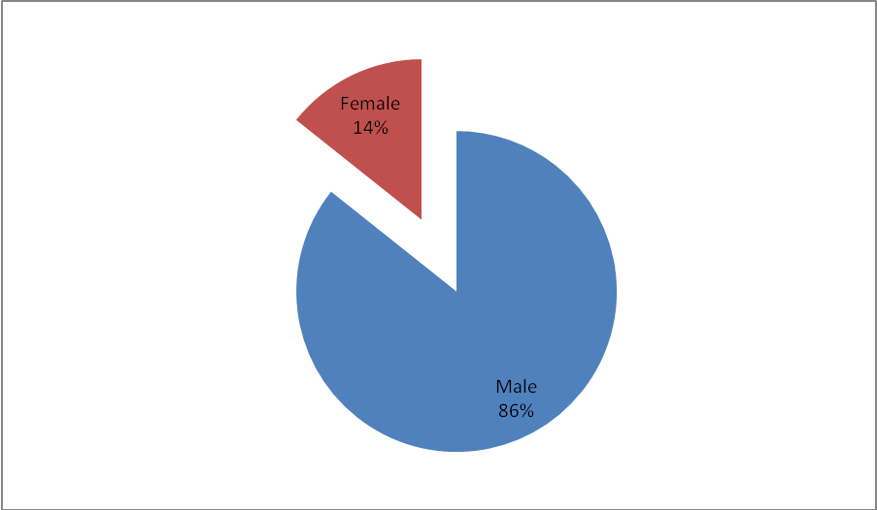

The table 4.2 and the figure 4.2 indicate the response on gender. The analysis clearly shows that many organizations had a higher number of males compared to female. The male were represented by 86% respondents while the females being the minority were represented by 14% of the total respondents. This implies that the gender balance rule was not met by different organizations.

4.2.3 Age Bracket
Table 4.3 Age Bracket
Age Bracket | Frequency | Percentage
18 – 25 years | 18 | 35
26 – 35 years | 11 | 25
36 – 45 years | 8 | 20
46 – 55 years | 5 | 13
56 years and above | 3 | 7
Total | 45 | 100
Source: Author (2019)
Figure 4.3 Age Bracket
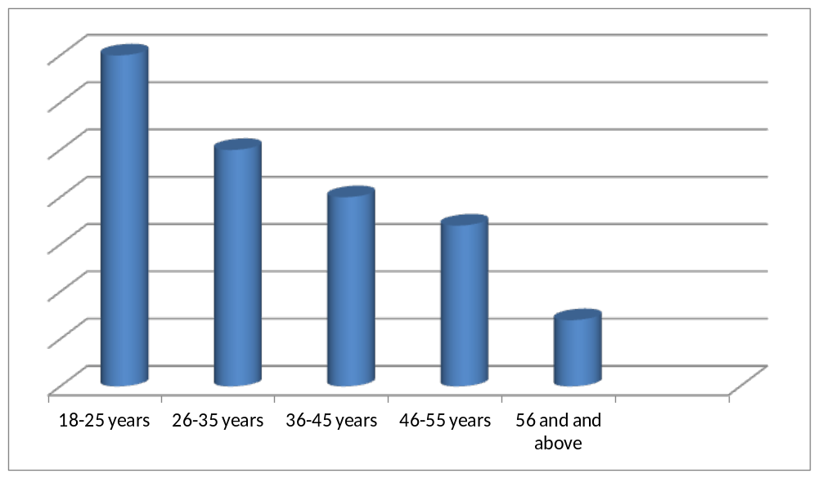
Source: Author (2019)
According to table 4.3 and figure 4.3 above, indicates the ages of the respondents analyzed. Form the analysis 35% of the total respondents being the majority were ages between 18-25 years, 26-35 years were represented by 25%, 36-45 years were 20% while those between 46-55, and 56 years and above were 13% and 7% respectively. From the above study it can be deduced that the majority of the respondents were between the ages of 18-25 years, young and energetic to work.

4.2.4 Highest Level of Education
Table 4.4 Highest Level of Education
Category | Frequency | Percentage
Primary | 6 | 5
Secondary | 9 | 23
College | 17 | 40
University | 10 | 25
Post Graduate | 3 | 7
Total | 45 | 100
Source: Author (2019)

Figure Highest Level of Education
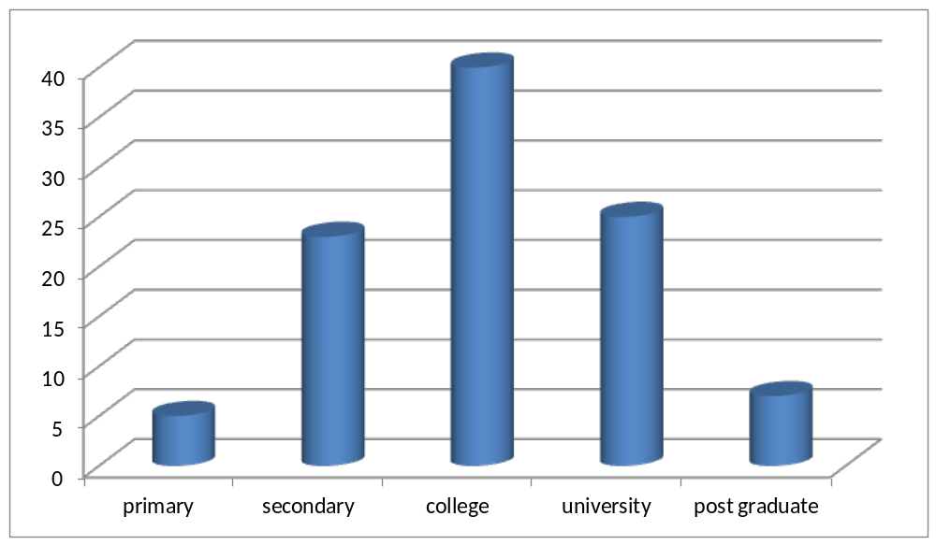

Source: Author (2019)
The above table 4.4 and figure 4.4 indicate the response on the highest education level. The response from primary level was 5%, secondary level was 23% while the response of college level was 40% being the majority, 25% were from university level and those who had post graduate qualification were 7%. From the analysis therefore it can be concluded that majority of the respondents had college qualification indicating good level of literacy at the organization operating in Gok State.

4.2.5 Duration of Working in the organization
Table 4.5 Duration of working
Duration of working | Frequency | Percentage
2 years and below | 10 | 5
3-5 years | 11 | 22
6-8 years | 15 | 46
9-11 years | 5 | 18
12 years and above | 4 | 9
Total | 45 | 100
Source: Author (2019)
Figure 4.5 Duration of working
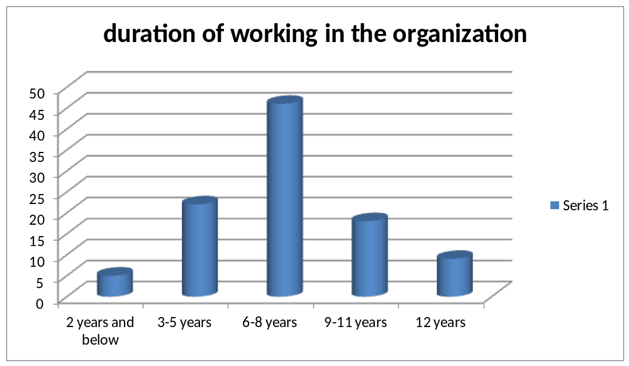

Source: Author (2019)
The above table 4.4 and the figure 4.4 indicate the duration of service to which the respondents have served in the organization. From the analysis 5% indicated that they have worked in the organization for less than 2years, 22% said that they have served for 3-5years while 6-8years, 9-11 years and 12 years and were represented 46%, 18% and 9% respectively. From the analysis majority of the respondents had good experience.

4.2.6 Respondent Category
Table 4.6 Respondent Category
Respondent Category | Frequency | Percentage
Top Level Management | 5 | 5
Middle Level Management | 30 | 78
Support Staff Management | 10 | 17
Total | 45 | 100
Source: Author (2019)

Figure 4.6 Respondent Category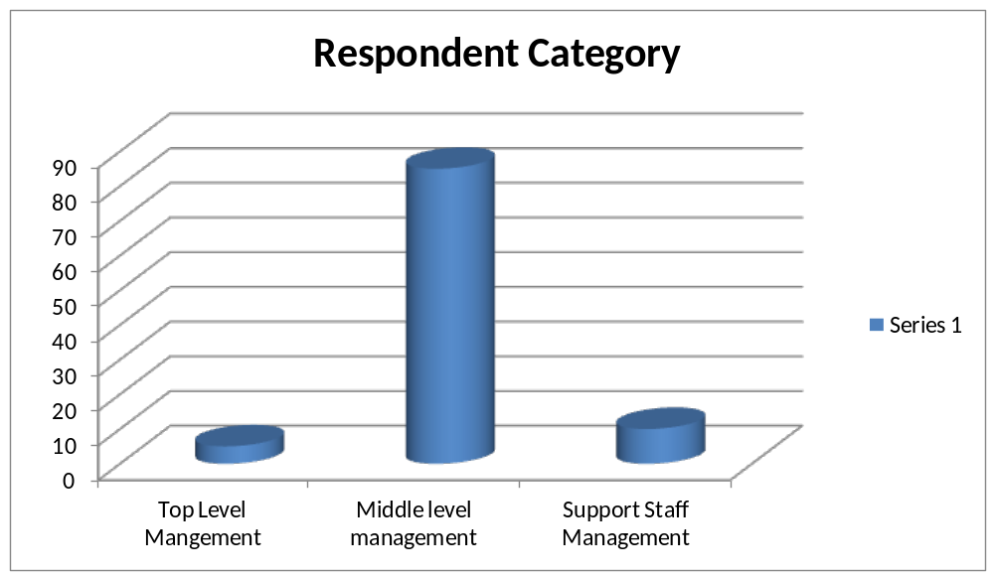

Source: Author (2019)
According to table 4.6 and figure 4.6 above shows the category of respondents in the organization. From the analysis 4
5% of the total respondents were top management, 10% were from support staff management while 85% comprised of middle level management (the majority). Based on the study findings it can be concluded that majority of the respondents were middle level management.
4.2.7 Monitoring
Table 4.7 Importance of monitoring
Category | Frequency | Percentage
Yes | 40 | 90
No | 5 | 10
Total | 45 | 100
Source: Author (2019)
Figure 4.7 Importance of monitoring
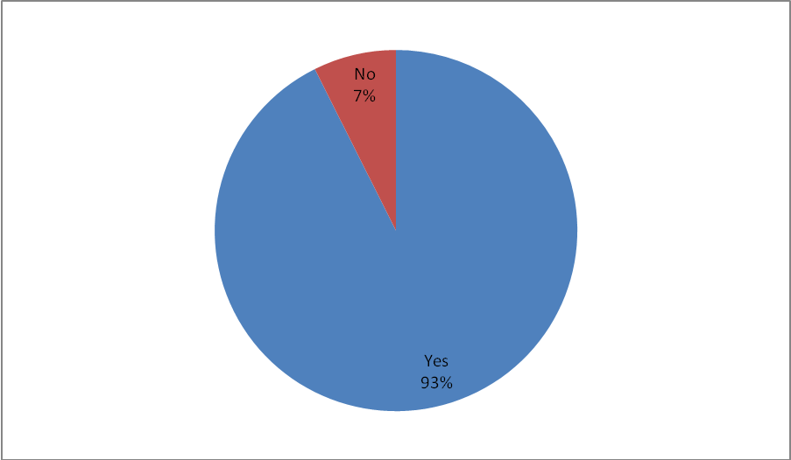
Source: Author (2019)
Table 4.7 and figure 4.7 above indicates the importance of monitoring. From the analysis 93% accepted that monitoring is very important while the remaining being the minority of 7% stated otherwise. Based on the findings majority of the respondents were of the opinion that monitoring is a factor to be considered when the project is on progress.

4.2.8 Rating of the important of the monitoring
Table 4.8 Rating of monitoring system
Category | Frequency | Percentage
Very High | 7 | 18
High | 12 | 30
Fair | 16 | 50
Low | 10 | 2
Total | 45 | 100
Source: Author (2019)
Figure 4.8 Rating of monitoring
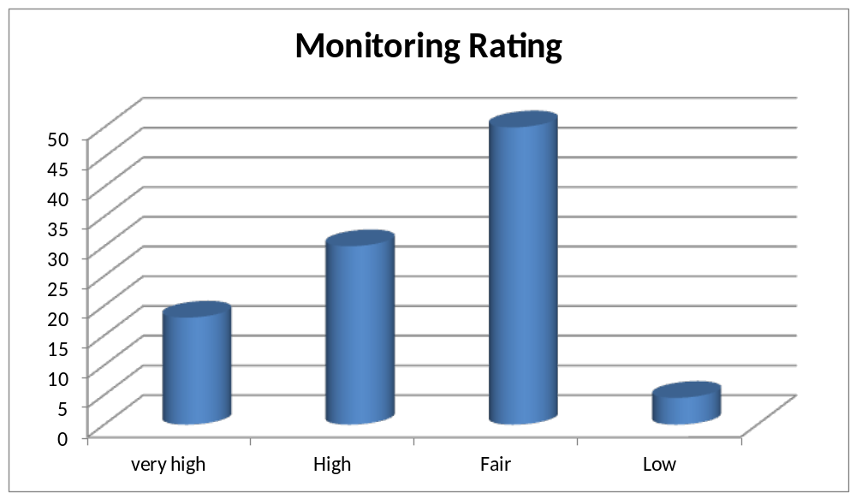

Source: Author (2019)
Table 4.8 and 4.8 indicates the rating of the importance of the monitoring is that. From the analysis 18% rated very high, 30%, 50%, and 2% rated high, fair and low respectively. Based on the analysis it can be concluded that monitoring is mostly conducted fairly which is suggested by 50% of the total respondents.

4.2.9 Data
Table 4.9 Importance of data collection
Category | Frequency | Percentage
Yes | 36 | 78
No | 9 | 22
Total | 45 | 100
Source: Author (2019)
Figure 4.9 Important of Data Collection
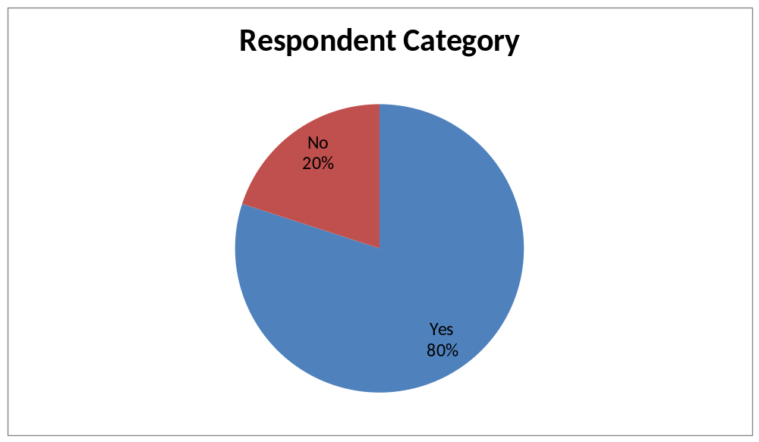

Source: Author (2019)
Table 4.9 and figure 4.9 indicates that Importance of data collection on project management. From the analysis majority of the respondents at 80% against the minority at 20% indicated that without data collection it can affect the progress of the project negatively. Based on the findings it can be inferred as that without proper data collection there is no progress on that organization.

4.2.10 Data Collection
Table 4.10 Rating of wrong data collection
Rating of wrong data collection | Frequency | Percentage
Very High | 18 | 45
High | 12 | 30
Fair | 10 | 15
Low | 5 | 10
Total | 45 | 100
Source: Author (2019)
Figure 4.10 Rating of wrong data collection
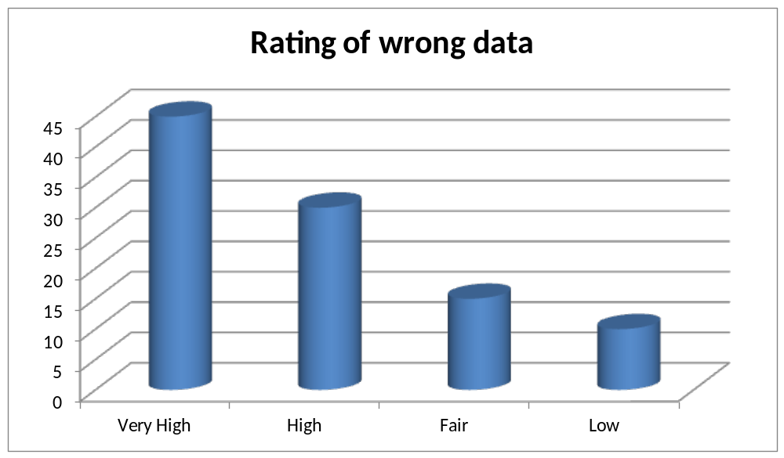

Source: Author (2019)
Table 4.10 and figure 4.10 shows the effect of wrong data collection. From the analysis majority of the respondents at 45% rated that data is not perfectly conducted very high, 30% rated high, 17% rated fair while the minority rated 10%. Based on the analysis it can be concluded that most of the data collectors cannot obtained accurate information due to ignorance and lack of knowledge and skills.
4.2.11 Evaluation
Table 4.11 Importance of Evaluation
Category | Frequency | Percentage
Yes | 40 | 89
No | 5 | 11
Total | 45 | 100
Source: Author (2019)
Figure 4.11 Effects of evaluation

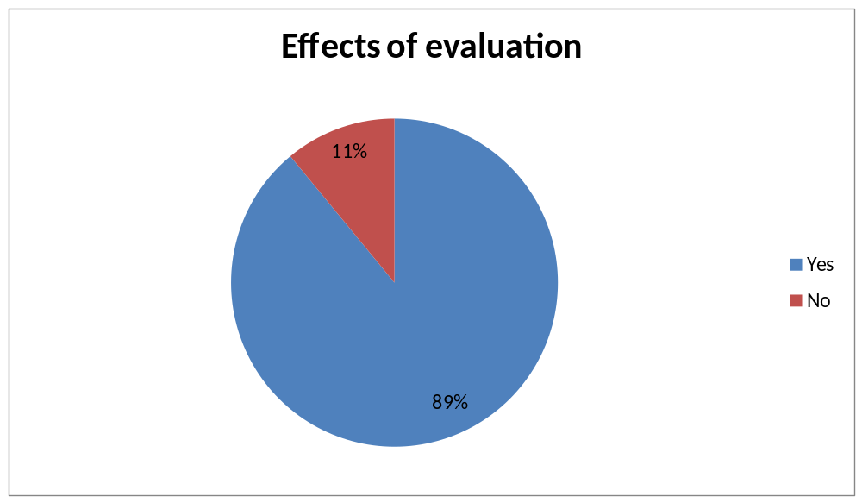
Source: Author (2019)
According to table 4.11 and figure 4.11 shows the effect of evaluation on project implementation. From the analysis majority of the respondents at 89% stated that Evaluation is positively affected by good monitoring system against 11% who stated that it does not. Based on the study it can be concluded that majority of the respondents said that Evaluation is positively affected by the objectives of the organization.

CHAPTER FIVE
SUMMARY OF FINDINGS, CONCLUSIONS AND RECOMMENDATION
5.1 Introduction
This chapter represents the study results in terms of introduction finding answers to research questions, study recommendations, conclusion and room for further study
5.2 Summary of findings
5.2.1. What are main challenges facing data collectors in your organization
The main challenges that the researcher had identify from the respondents are, language barrier, resistance from the community leaders and respondents, insecurity, roads accessibility, transport challenges/ logistical issues and conflicts with compensation.
5.2.2 What can be done to address the challenges facing data collectors working in humanitarian organizations in Gok State- Cueibet?
The researcher had also identify the solutions to the problems facing data collectors as follows; training of staff on safety and security management, providing means of transport for data collectors, Data collectors should keep participants or respondents information confidential, data collection projects should be well financially sponsored.
5.2.3 Would you rate the effect of wrong data collection in the developmental projects in Gok state?
From the analysis majority of the respondents at 45% rated that data is not perfectly conducted very high, 30% rated high, 17% rated fair while the minority rated 10%. Based on the analysis it can be concluded that most of the data collectors cannot obtained accurate information due to language barrier, lack of knowledge and skills.
5.2.4 Briefly describe the importance of data collection?
- To inform the project staff on proper planning
- To make decision based on information got from data
- To inform decision makers on the findings from the field in review of progress and challenges facing a particular project being implemented.
5.2.5 What are the factors consider when collecting data?
Majority of the respondents have stated the following: Accuracy, period of implementation (time), cost of the activity, and validity and reliability of the data needed.
5.2.6 Discuss the qualities of a good data
- Questions should be short and simple to understand
- Accuracy and precision
-it should be reliable and consistent
- Availability and accessibility
- It should be complete and comprehensive
5.2.7 What are the causes of wrong data collection in the organization concern?
Most the staff and project managers stated that wrong data can come as results of the following, Data entry mistakes, flaw data entry process, the null problem, deliberate errors, systems problems.
5.2.8 In your opinion suggest ways in which the issue of wrong data collection can be improved to facilitate the smooth running of the project.
- To provide members of data collection with equipments and tools plus facilities.
- Every project that carryout data collection should undergo the process of verification.
- All data collectors should be well qualified, trained and have experience in the field of data collection.
5.2.9 Briefly explain the methods used for collecting data in your organization
Majority of the respondents have identified and explain the following methods of data collection their respective organizations:
- Qualitative method through surveys and questionnaires
- Clients interviews methods
- Focus groups discussion methods
- Direct observation method
- Quantitative method
5.3 Conclusion
Based on the findings, the researcher had identified the challenges facing data collectors as well as the effects and the ways of addressing them which are all important in project management.
5.4 Recommendations
1. Based on the findings, I recommendated all data collection projects should be well financially sponsored.
2. Data collectors chosen should be well qualified, experienced and trained.
3. Supervision should be ensured during all stages of data collection.
4. Tools for gathering data should be simple to understand
5. Government should improved the security in the areas of project implementation
5.5 Suggestions for Further Study
The researcher suggested a need for further research because the survey had not exhausted all the problems associated with project management, their effects and how to prevent them in the organizations that are operating in South Sudan. Areas suggested for further research include the use of variables such as an investigation on project failure as dependent variables

REFERENCES

Cabrera, D., Colosi, L., & Lobdell, C. (2008). Systems thinking. Evaluation and Program Planning 31, 299-310.
Conlin, S. and Stirrat, R. (2008). Current challenges in development evaluation. (pp.193-208) Evaluation 14(2). Sage Publications

Hogan, R. L. (2007). The historical development of program evaluation: Exploring the past and present. Online Journal of Workforce Education and Development 2(4). Eastern Illinois University.

Independent Evaluation Group and Carleton University. (2007). Module 1: Introduction to development evaluation. (pp.9-30) International Program for Development Evaluation Training (IPDET) Handbook, The World Bank Group.

Roche, C. (1999). Impact assessment for development agencies: Learning to value change. Oxford, UK: Oxfam GB.

United Nations ACC Task Force on Rural Development, Panel on Monitoring and Evaluation [referenced as UN Taskforce]. (1984). Guiding principles for the design and use of monitoring and evaluation in rural development projects and programmes. Rome. (ACCAdministrative Committee on Coordination)

Shamoo, A.E., Resnik, B.R. (2003). Responsible Conduct of Research. Oxford University Press.
PAANLUEL WEL MEDIA LTD- SOUTH SUDAN, 2017, Profile of Cueibet town.
Nicol,D.J and Macfarlane-Dick,D. (2006) formative assessment and self-regulated learning
Trumbull, E., & Lash, A. (2013). Understanding formative assessment: Insights from learning
theory and measurement theory. San Francisco: WestEd

APPENDIX II
RESEARCH QUESTIONNAIRE

My name is Moses Mabor Tom, I’m pursuing a Diploma in Monitoring And Evaluation at Strategia Netherlands .I’m given this research study to know the challenges facing data collectors in South Sudan: Case study Gok State – Cueibet, I‘m targeting project co-ordinators, project Managers, project staffs and retired intellectuals from the institutions or humanitarian organizations operating in Gok State.

Am requesting you to participate in the study and If you kindly agree to participate than any information that is going to be obtained from you will be kept confidential. Your name will not be mentioned or identified in any report.
Also you are free to withdraw at any time if you feel uncomfortable with the questions.

Respondent.

I have read and understood the entire document and I have accepted to participate in the research conducted by Moses Mabor Tom; That will involve me providing my opinion on questions in relation to the challenges facing data collector in Gok State- Cueibet.
I voluntarily sign this agreement.
Name: _____________________________ Signature: ___________________
Phone number: ________________________
Date: __________________________

Interviewed by:
Name_________________________ Signature/ ___________________
Date: ___________________________ Contact: 0923020006

Kindly answer the questions by putting a tick in the appropriate box or by writing in the space provided.

SECTION A: GENERAL INFORMATION
- Gender:
Male { }
Female { }
- Age:
Between 18-25 { }
Between 26-35 { }
Between 36-45 { }
Between 46-55 { }
Above 55 { }
- Level of Education:
Primary { }
Secondary { }
College { }
University { }
Post Graduate { }
- Duration of working in your organisation
2 years and below { }
3-5 years { }
5-8 years { }
9-11 years { }
12 years and above { }
- Respondent Category
Top Level Management { }
Middle Level Management { }
Support Staff Management { }

SECTION. B Monitoring

- (a) Does your organization carryout data collection?
Yes { }
No { }
(b) Briefly explain the methods used for collecting data in your organization
……………………………………………………………………………………………………………………………………………………………………………………………………………………………………………………………………………………………………………………………………………………………………………………………………………………………………………………………………
- Is the collection of data important in the project management?
Yes { }
No { }

b). Briefly describe the importance of data collection? …………………………………………………………………………………………………………………………………………………………………………………………………………………………………………………………………
…………………………………………………………………………….
8. What are the factors consider when collecting data?
……………………………………………………………………………………………………………………………………………………………………………………………………………………………………………………………………………………………………………………………………………………………………………………………………………………………………………………………………………………………………………………………………………………………………………………………………
9. Discuss the qualities of a good data

………………………………………………………………………………………………………………………………………………………………………………
………………………………………………………………………………………………………………………………………………………………………………………………………………………………………………………………………………………………………

10. What are the causes of wrong data collection in the organization concern?
………………………………………………………………………………………………………………………………………………………………………………………………………………………………………………………………………………………………………………………………………………………………………………………………………………………………………………………………………………………………………………………………………………………………………………………………………………………………………………
11. What are main challenges facing data collectors in your organization
………………………………………………………………………………………………………………………………………………………………………………………………………………………………………………………………………..
………………………………………………………………………………………………………………………………………………………………………………………………………………………………………………………………………………………………………………………………………………………………………………………………………………………………………………………………………………………………………………………………
12. What can be done to address the challenges facing data collectors working in humanitarian organizations in Gok State- Cueibet?
………………………………………………………………………………………………………………………………………………………………………………………………………………………………………………………………………………………………………………………………………………………………………………………………………………………………………………………………………………………………………………………………………………………………

13. How would you rate the effect of wrong data collection in the developmental projects in Gok state?
Very High { }
High { }
Fair { }
Low { }

14. In your opinion suggest ways in which the issue of wrong data collection can be improved to facilitate the smooth running of the project.
………………………………………………………………………………………………………………………………………………………………………………………………………………………………………………………………………………………………………………………………………………………………………………………………………………………………………………………
15. Is monitoring important in project management?
Yes { }
No { }
b) If yes, outline the importance of monitoring
………………………………………………………………………………………………………………………………………………………………………………………………………………………………………………………………………………………………………………………………………………………………………….

SECTION. C Evaluation
16. Is evaluation important in project management?
Yes { }
No { }
b) If yes, outline the importance of Evaluation
………………………………………………………………………………………………………………………………………………………………………………………………………………………………………………………………………………………………………………………………………………………………………………………………………………………………………………………

Put the circle or tick around the correct answer.

17. One of the following is the reason for conducting an evaluation.
A. To provide managers with information, projects plans, strength and weakness, delivery of services and decision making.
B. To improve program managers with knowledge.
C. For beneficiaries.
D. For community seek.

18. Monitoring and Evaluation is important because,
A. it provides the only consolidated source of information showcasing project progress.
B. it improve the manager’s income.
C. it provides the salary structure
D. To maintain the staff.
19. For an any monitoring and evaluation to be useful, the organization must ensure that the
Evaluation is:-
- Corrupt
- Must be very easy
- Independent, intentional, transparent.
- Must have logistics

Thanks you for your cooperation

